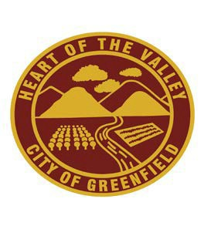
City of Greenfield
Parks and Recreation Committee

GREENFIELD COMMUNITY CENTER
1351 OAK AVENUE
Greenfield, CA 93927

Special Meeting Agenda

Monday March 18th, 2024
5:00 P.M.
Your courtesy is requested to help our meeting run smoothly.
Please follow the rules of conduct for public participation in the meetings: Refraining from public displays or outbursts such as unsolicited applause, comments, or cheering; Any disruptive activities that substantially interfere with the ability of the Committee to carry out its meeting will not be permitted, and offenders will be requested to leave the meeting. Please turn off cell phones and pagers.

CALL TO ORDER / ROLL CALL
Chair Vasquez, Vice Chair Villarreal, Members McClure, Rodriguez, and Uribe

- PUBLIC COMMENTS FROM THE AUDIENCE REGARDING ITEMS NOT ON THE AGENDA
This portion of the agenda allows an individual the opportunity to address the Committee on any items, not on the agenda. A three-minute time limit may be imposed on all speakers other than staff members.

- APPROVAL OF FEBRUARY 5TH MEETING MINUTES
  - Oral Report
  - Public Comments
  - Committee Comments / Review / Action

- DISCUSSION OF CIP OPTIONS: PATRIOT PARK RESTROOMS AND DOG PARK PROJECT PRESENTATION
  - Oral Report
  - Public Comments
  - Committee Comments / Review / Action

- TENNIS COURT CIP DISCUSSION- CURRENT SURVEY RESULTS
  - Oral Report
  - Public Comments
  - Committee Comments / Review / Action

- FINAL COMMENTS FROM COMMITTEE MEMBERS AND STAFF

- ADJOURNMENT
************************************************************************************************************************************************************************ In compliance with the American With Disabilities Act, if you need special assistance to participate in this meeting, please contact the City Clerk
at (831) 674-5591. Notification 48 hours prior to the meeting will enable the City to make reasonable arrangements to ensure accessibility to the
meeting (CFR 35.102-35.104 ADA Title II).
This agenda was duly posted outside the Greenfield Community Center, City Hall and on the City of Greenfield web site.

